CSIT214 Weekly Meeting:

Week 9:
Meeting Date: Week 9 (didn’t have one)
Group Members:
- Zac Wastie
- Jay Segar
- Nikita Kravchenko
- Zexi Dong
- Sui San Cheung
Focus for this week.
The focus for this week was to assign all the left over roles that had not been chosen yet and get the final logo design
Progress Report
Week 7 was a super productive week as communication between all group members was at an all-time high. We had an online meeting on Monday, and it was mainly just a catch-up meeting where we showed what we have done so far. Nikita had a lot of work to show which was good to see, especially with the start of the website design. The team was happy with how it was going. We also had a lot of the report completed including Introduction, Risk Management, and Justification for Project Selection, and we have started the Business Case.

Week 9 we got the communication back to where we wanted it to be. We had a meeting planned for Thursday at 2:00PM but it had to be cancelled as there was some members that couldn’t attended it. So, Zac and Zexi had some private communication and decided that we will give the remaining roles that had not been chosen yet to the group members. The website design is going well and all the members like our home page design. It was also the deadline for the logo we will propose to flydream as they go through the rebranding. This week was good as we had also completed the business case section on the report and the project charter. Other sections need to be done but we still have time to get them done.
Our Roles
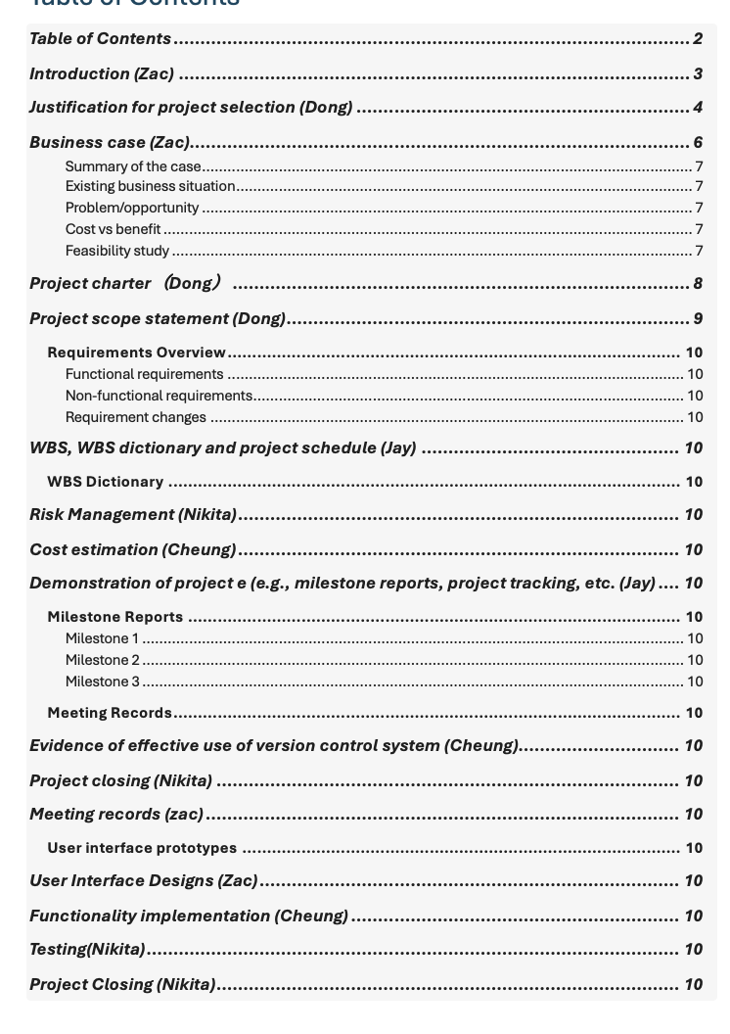

Logo:
